Real Time Rendering Techniques

Coursework 1 – Full Screen Anti-Aliasing

Gregory Neale

2019

Table of Contents

The Scene 2

Base Image 4

MSAA 5

2x 5

4x 5

8x 6

16x 6

32x 7

SSAA 8

2x 8

4x 8

8x 9

Comparison 10

Conclusion 13

Sources 14

Code Appendix & Full Data Collection 14

# The Scene

My scene was inspired by the XPlus commercials in cinemas that depict a character “experiencing” some higher level of entertainment. I decided to create a fictional company and set my scene as an advert of sorts. The scenes features are:

* 7 models
  + Each with UV unwrapped textures
* 2 point lights
  + One in ceiling light
  + One in PC
    - RGB spectrum enabled
* 1 directional light
  + Coming from the star on the skybox (below the platform)
* Skybox
  + Has custom image (source listed below)
* Anti-Aliasing capabilities
  + MSAA
    - Above 32x but only tested to 32x
  + SSAA
    - On home PC could only do up to 8x.
* Moveable camera

Here are some images with SSAA 8x:

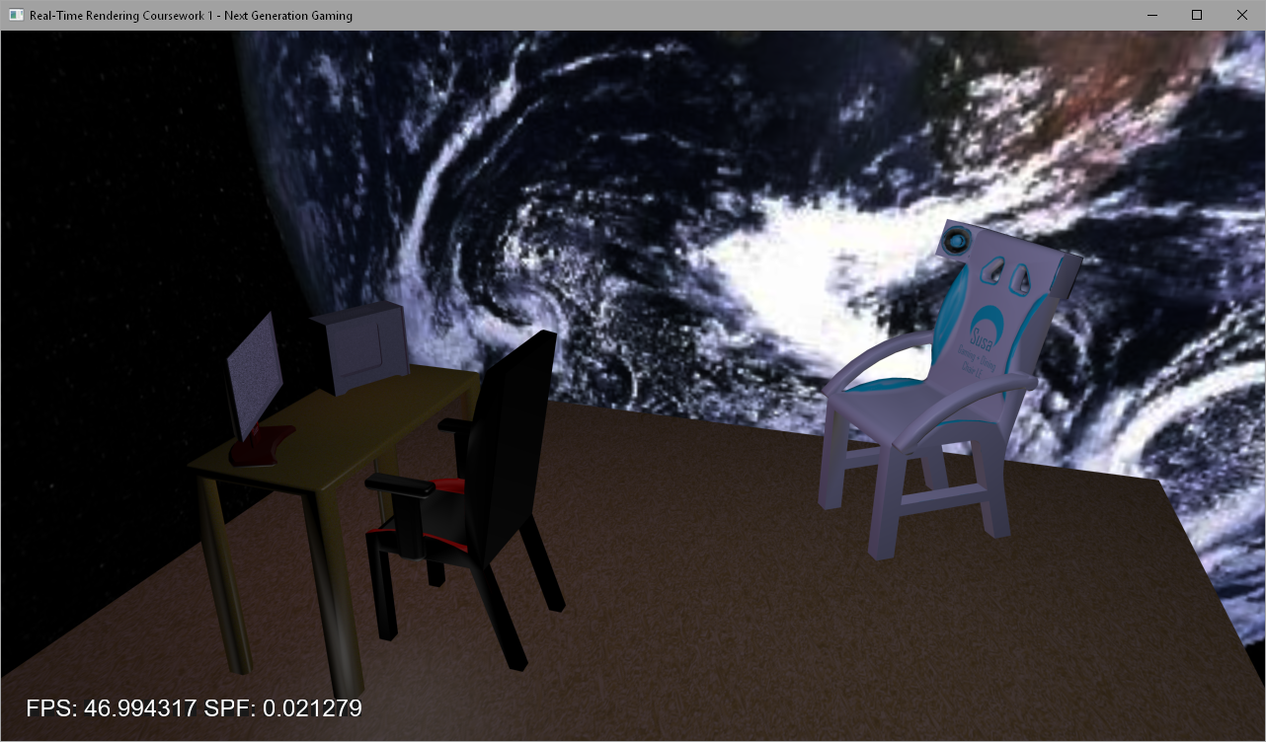

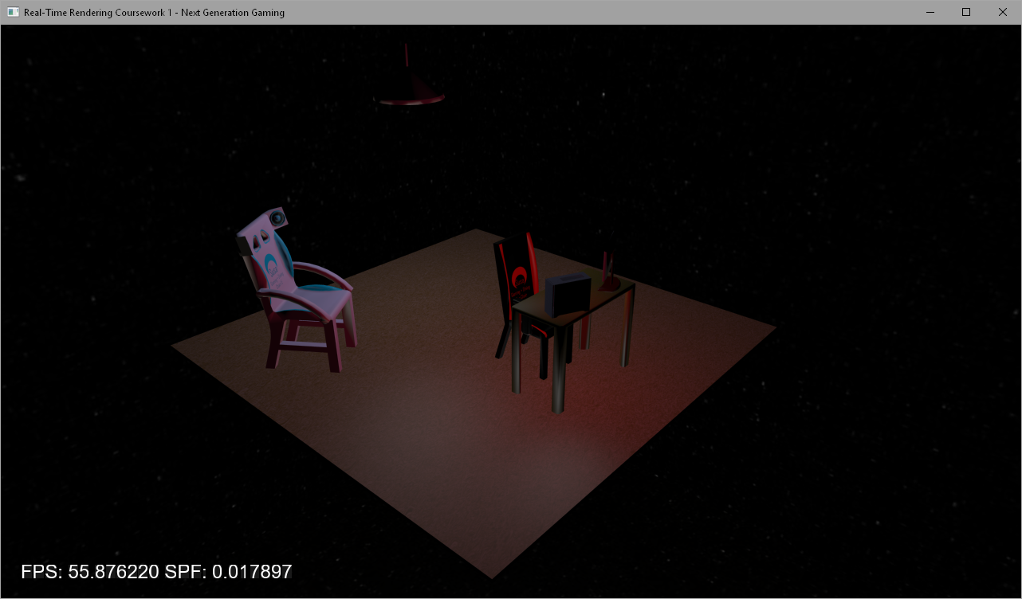

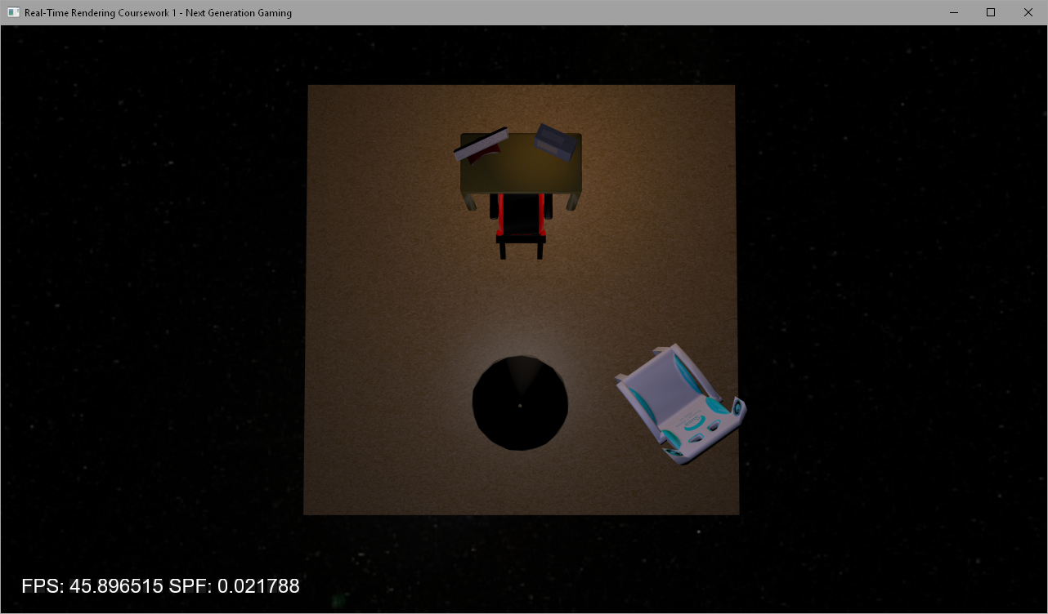

# Base Image

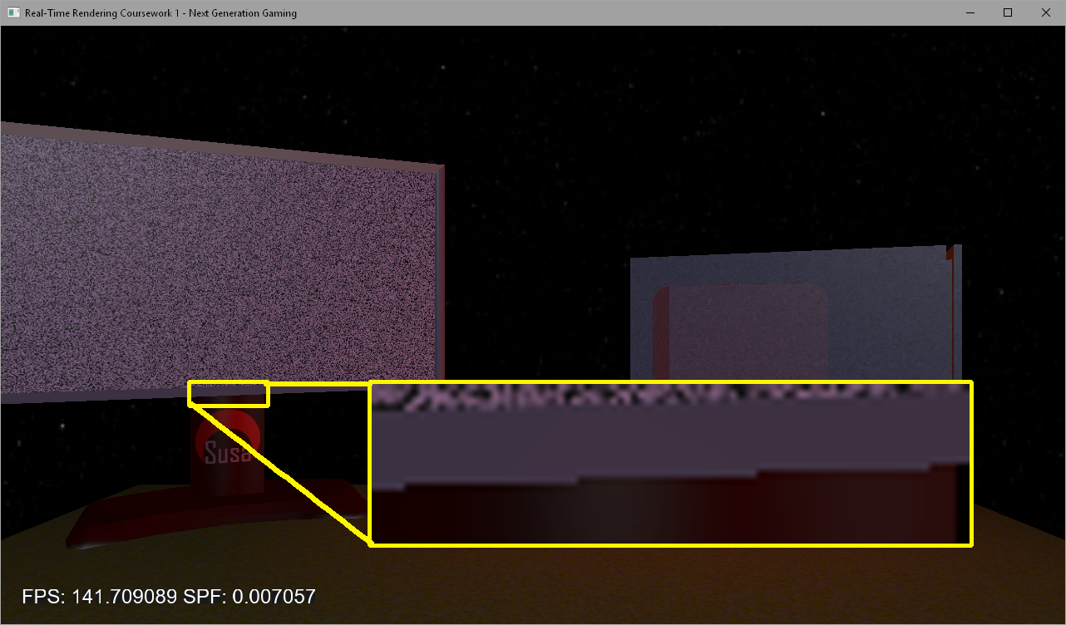

Each of the images below will follow this format. This image does not have any anti-aliasing enabled, however, the images below will. The yellow rectangle is the enlarged version of the smaller rectangle.

# MSAA

MSAA proved to have minor results from 2x through to 32x.

## 2x

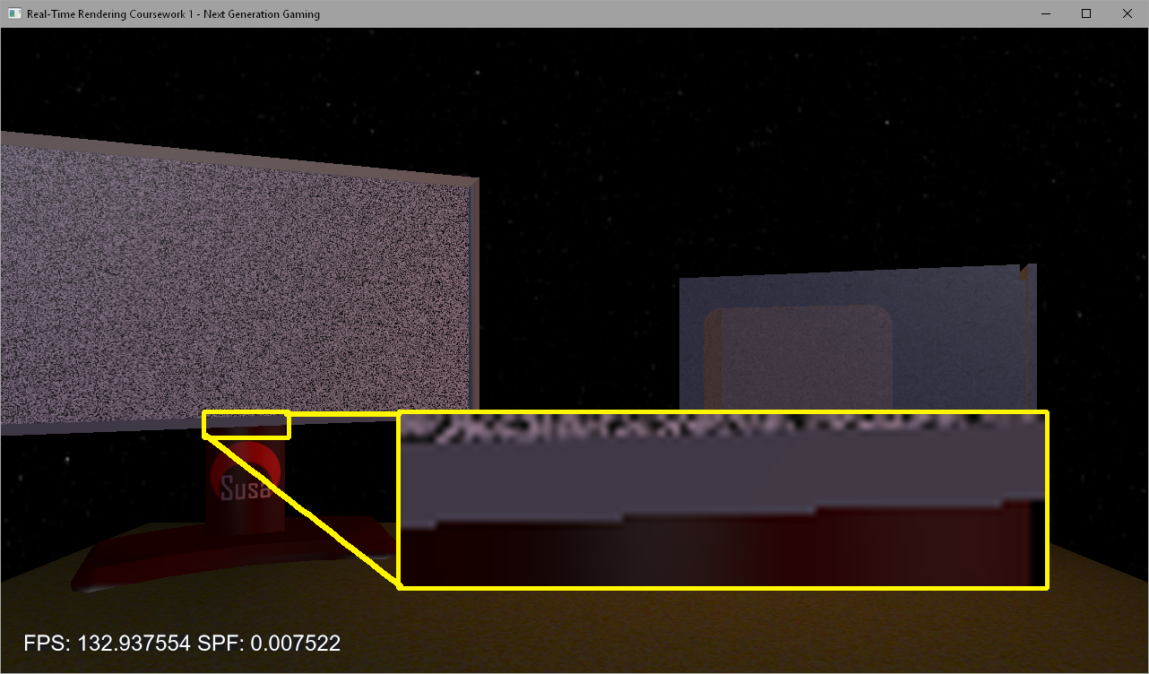

Almost no difference to no AA. “Jaggies” are still very visible.

## 4x

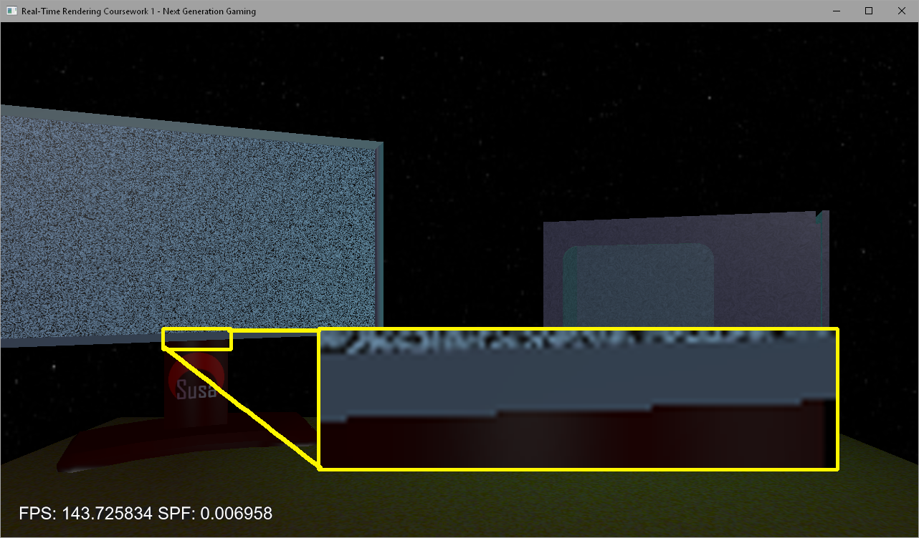

A slight change in colour can be seen from the red to the grey.

## 8x

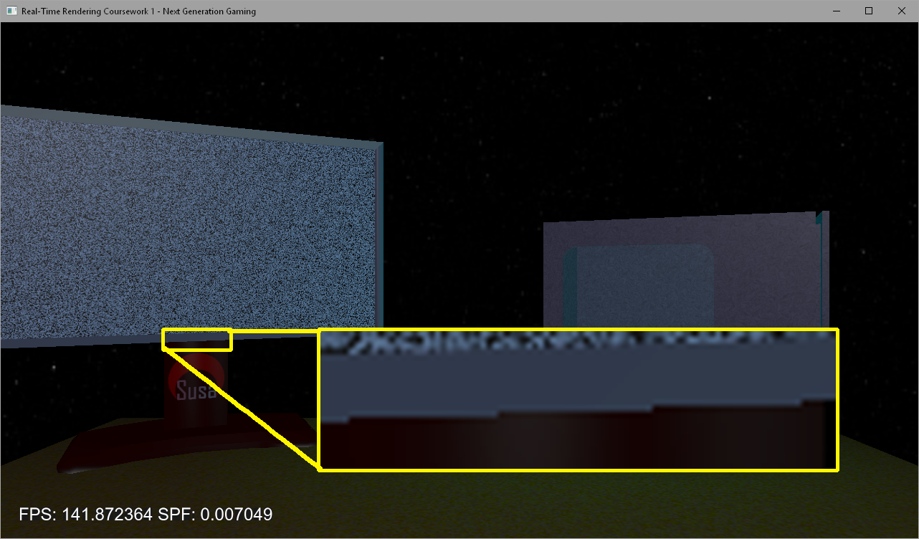

Harshness of “jaggies” greatly reduced, however, they are still present.

## 16x

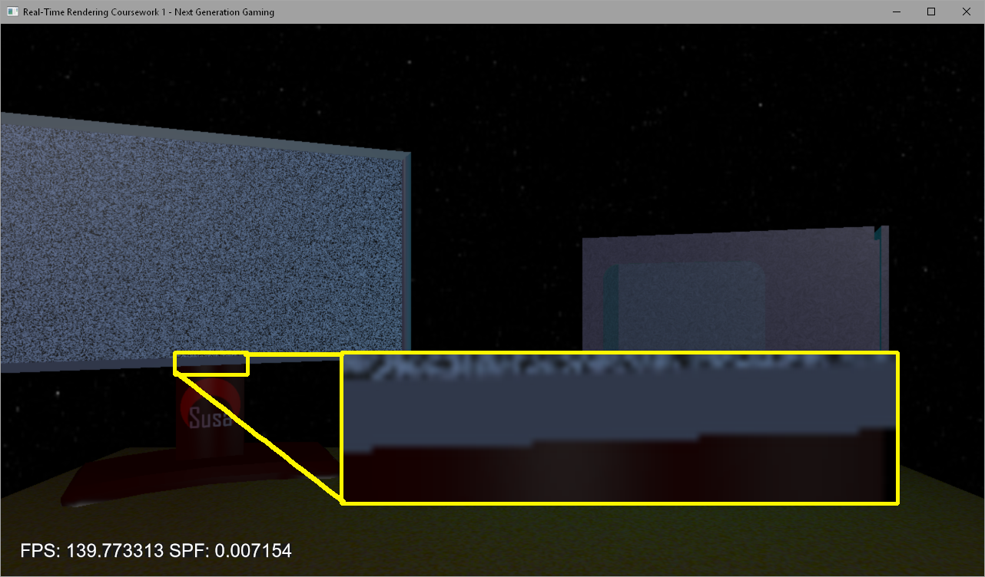

Much smoother edge, however, “jaggies” are still present.

## 32x

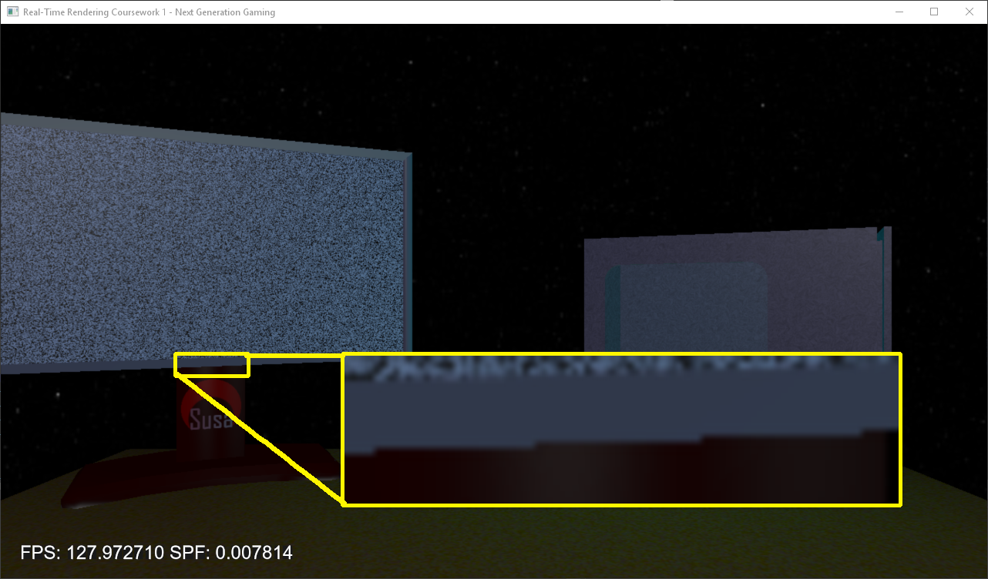

By far the nicest looking edge, however, there are still major “jaggies”.

# SSAA

## 2x

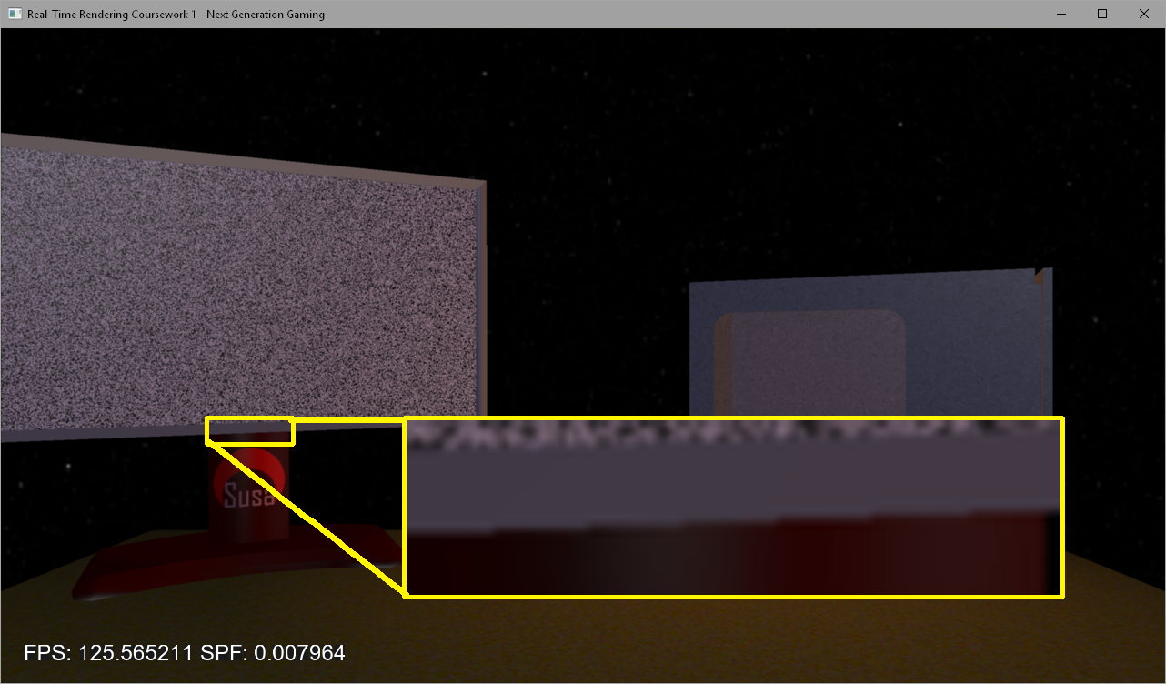

Many “jaggies” are removed, however, the edge is not super smooth.

## 4x

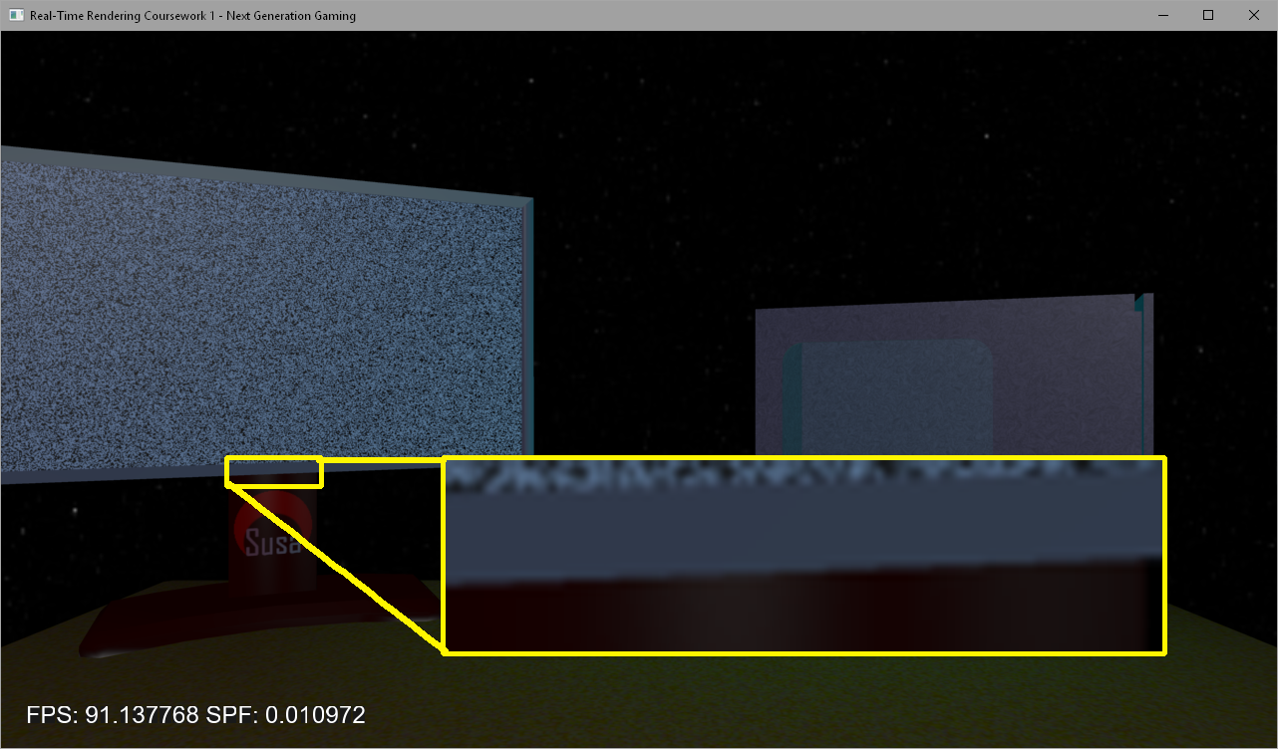

Many “jaggies” removed and the edge is much smoother than 2x, however, there are still some harsh edges remaining.

## 8x

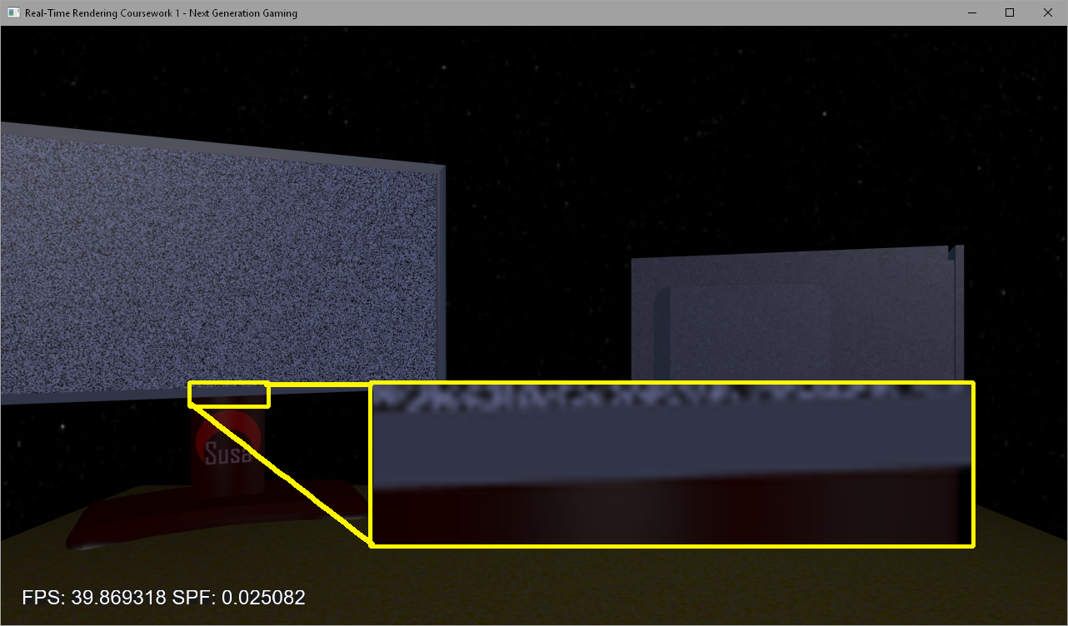

Edge is completely smooth.

# Comparison

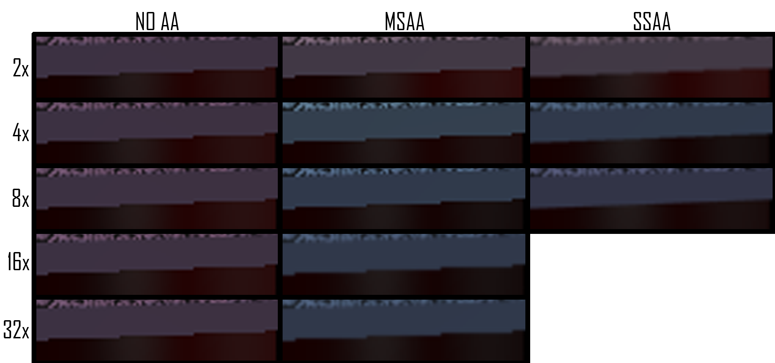

This image clearly shows the differences between the anti-aliasing methods demonstrated within the screen. The sample taken is the highlighted area within the pictures above, but magnified so that the “jaggies” can be seen clearly. As NO AA has no anti-aliasing the image remains the same. MSAA adds a slight “fade” of sorts to the edges and makes the changes from one colour to another less sudden. SSAA makes the edge seem as it should with much better lines and smoother edges.

As the increase in samples provides increasingly greater results with MSAA, with each increase in samples, SSAA’s differences seem to get smaller and smaller. SSAA 4x and SSAA 8x only have minor differences, but the performance payoff is huge.

There is also quite a difference between the way that the textures appear depending on the sampling. MSAA left textures as is with only slight modifications to colours, however, SSAA would occasionally reduce detail and produce a smoother looking texture, which was overall a nicer appearance.

This graph shows the relation between SPF and FPS. The higher the FPS, the lower the SPF and vice versa. The graphics card struggled much more with SSAA 4x and 8x than anything else which can be seen by the Average SPF for those methods.

|  |  |  |
| --- | --- | --- |
|  | Average FPS | Average SPF |
| Base | 950.6063 | 0.001052 |
| MSAA 2x | 904.2107 | 0.001106 |
| MSAA 4x | 926.9118 | 0.001079 |
| MSAA 8x | 906.77 | 0.001102 |
| MSAA 16x | 738.37 | 0.001356 |
| MSAA 32x | 832.9276 | 0.001201 |
| SSAA 2x | 741.6328 | 0.001349 |
| SSAA 4x | 188.2295 | 0.005358 |
| SSAA 8x | 26.48507 | 0.037894 |

When looking at the table it is shows a clearer relation between the SPF and the FPS. A clear relationship can be seen with a low FPS being related to a high FPS.

Average Seconds Per Frame (Lower is much better).

SPF is the time it takes the GPU to render and deliver each frame. The faster it can do it, the better it is.

In this graph, it is clear to see that all MSAA and SSAA 2x does not create much of an impact on the SPF as it maintains well below 0.005. However, with SSAA 4x and 8x a clear and dramatic increase in SPF was recorded, with 8x taking over 7 times longer to render than the 4x sample size.

|  |  |
| --- | --- |
|  | Average SPF |
| Base | 0.001052 |
| MSAA 2x | 0.001106 |
| MSAA 4x | 0.001079 |
| MSAA 8x | 0.001102 |
| MSAA 16x | 0.001356 |
| MSAA 32x | 0.001201 |
| SSAA 2x | 0.001349 |
| SSAA 4x | 0.005358 |
| SSAA 8x | 0.037894 |

The table shows more accurate data and the previously made point is further emphasized. The most confusing part about this data is the performance rates for MSAA do not seem to scale at all when increased, with 32x having a lower SPF than 16x. SSAA on the other hand made the average SPF increase exponentially. Without producing higher sample sizes for SSAA it is difficult to estimate the rate at which the performance impact increases.

Average Frames Per Second (Higher is better)

This graph tells us very little. The FPS seems to be higher with MSAA 32x than it is with MSAA 16x, which theoretically speaking is ridiculous. The fluctuations between the datasets seem random and illogical.

A clear decrease in FPS can be seen with SSAA 4x and SSAA 8x, similarly to the increase in SPF discussed above.

|  |  |
| --- | --- |
|  | Average FPS |
| Base | 950.6063 |
| MSAA 2x | 904.2107 |
| MSAA 4x | 926.9118 |
| MSAA 8x | 906.77 |
| MSAA 16x | 738.37 |
| MSAA 32x | 832.9276 |
| SSAA 2x | 741.6328 |
| SSAA 4x | 188.2295 |
| SSAA 8x | 26.48507 |

The table further emphasizes the illogical pattern shown with the MSAA data. Huge fluctuations occur, however, when compared to the SPF, there is very little difference.

# Conclusion

FPS can be used as a good measure for performance, however, in this case we can see that with MSAA the data makes little to no sense. I believe this inconsistency is within the error margin for MSAA, with 16x and 32x only producing slightly fewer frames. The inconsistency may have been caused by external factors such as background processes running at the time.

SSAA clearly produces the best results as it smooths edges. MSAA seems to have more of an impact on textures and less on the actual edges themselves. Only a slight blur can be seen.

For optimal performance with Anti-Aliasing enabled and visual differences, MSAA can be recommended. It has the least impact on performance, however, the visual quality is quite lacking, with very slight fades being added around harsh edges.

For optimal visual fidelity, SSAA can be recommended. SSAA 8x hampers performance greatly, however, the improved visual quality is insane. At SSAA 4x the “jaggies” are almost completely removed. At SSAA 8x the edge is smooth and no “jaggies” can be seen.

Overall, for the best of both worlds, SSAA 2x seems to be a very good choice. The edges and textures receive clear improvements and the performance is not impacted very much.

A combination of the two is possible, however, SSAA 2x does a very good job at exactly what MSAA does.

# Sources

RDG Point light: <https://krazydad.com/tutorials/makecolors.php>

Skybox Texture: <http://www.custommapmakers.org/skyboxes.php>

# Code Appendix & Full Data Collection

The following code consists of code that was edited by me.